Chapter 9, Problem 58.

Using Fig. 9.65, design a problem to help other students better understand impedance combinations.
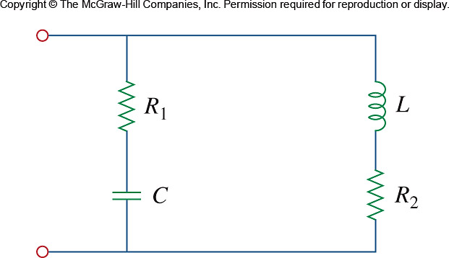

Figure 9.65
For Prob. 9.58.

